Xamarin BDD MVVM App Developer’s Guide

Section 0: Overview 1

Project Credentials 1

User Story: 2

Restrictions and Requirements (MoSCoW method) 2

Acceptance Tests 2

Reference and Credits: 2

Section I Preparing to Develop the app 2

Install Development IDE 2

Install BDD Framework 2

Create Main Solution: 3

Setup the MVVMLight framework 6

Add BDD Project 7

Refactoring the Shared Project to MVVM model 10

Structure of an MVVM page 10

Adding the First Page 11

Running The Sanity Tests 12

Selecting Android Emulator to run 12

Selecting iOS Simulator to run 13

Running tests on Xamarin Test Cloud 15

Running tests locally 15

Section 2- General Techniques in Developing the Application 17

The TDD/BDD protocol 17

Writing the smallest failing test: 17

Making the test pass with minimum code 21

Using app.Repl() 22

Refactor, and Repeat. 22

Adding Button Actions to the application 23

Navigation to other pages 23

Testing a new page 25

Creating a Page Test Object 25

Scenario for a button navigating to page 26

Section 0: Overview

# Project Credentials

contact point: Reza Alemy (author), reza@alemy.net

# User Story:

**As a** Mobile App developer

**I want** to have a boilerplate example of using BDD and MVVM-Light in Xamarin framework

**So that** I can develop multiplatform apps that use the BDD technique for testing and MVVM-light for component management.

# Restrictions and Requirements (MoSCoW method)

* The boilerplate project MUST show how to use Visual Studio to set up the app codebase
* The boilerplate project MUST show how to add Specflow for BDD support to the app codebase
* The boilerplate project MUST show how to write Specflow steps in Xamarin.UITest framework
* The boilerplate project MUST show how to add pages and components using MVVM-Light framework

# Acceptance Tests

Given: The repo is cloned

When: I read the documentation included

Then: I have a step by step explanation on how to setup and develop Xamarin apps using Specflow and MVVM.

# Reference and Credits:

Rob Gibbens article for Specflow:

<http://arteksoftware.com/bdd-tests-with-xamarin-uitest-and-specflow/>

Section I Preparing to Develop the app

# Install Development IDE

Selected Technology: Visual Studio, C# language on Xamarin framework

Presented Environment: Visual Studio for Mac

Downloaded from: <https://www.xamarin.com/download>

Version: 7.2.2 (build 11)

# Install BDD Framework

Selected Technology: Gherkin BDD language

Presented as Visual Studio for Mac Extension: Specflow for mac

Downloaded from: <https://github.com/straighteight/SpecFlow-VS-Mac-Integration/releases/tag/1.11.0.0>

To install, go to 'Visual Studio.../Extensions...' click the button on the far left saying "Install from file..." and select the mpack file from your hard drive. The addin will install and you can now run and creat specflow tests

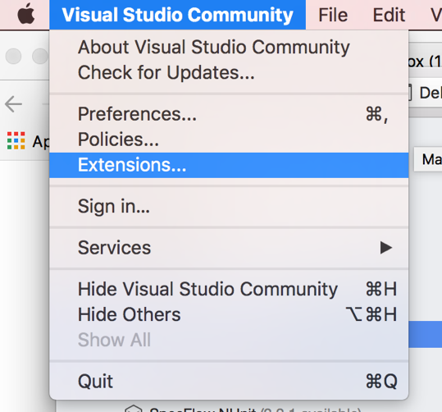

Restart Visual Studio for Mac

# Create Main Solution:

Create a solution with Android and iOS.

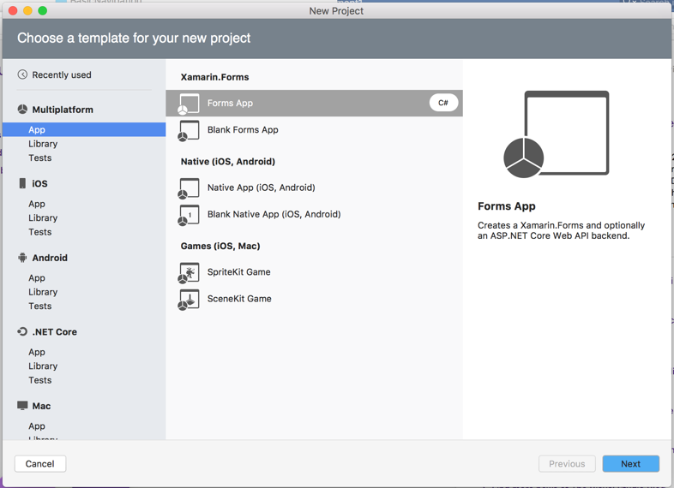

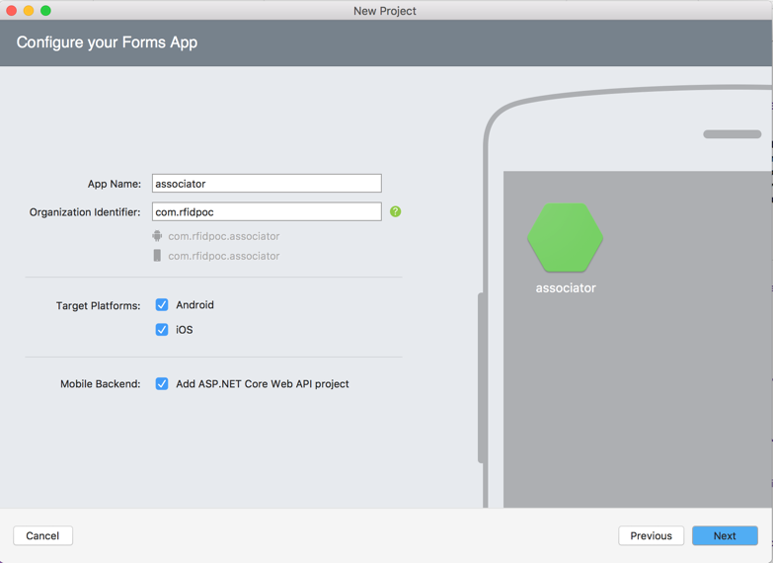

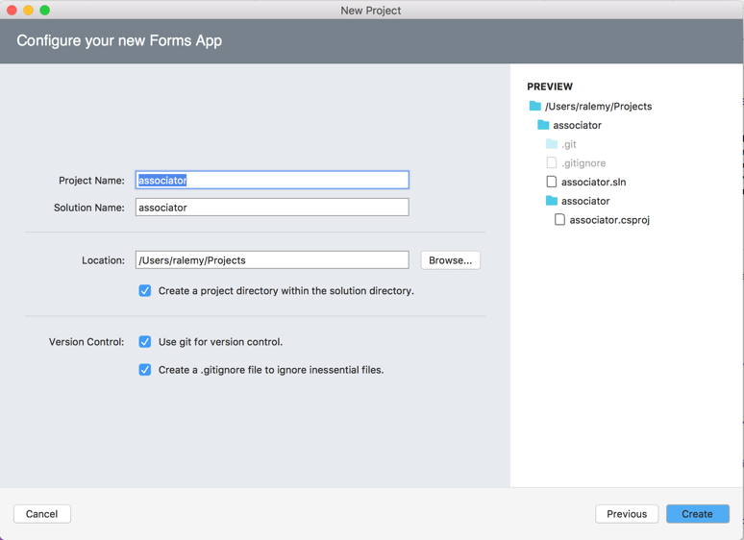

Target the latest Android framework for the Droid project (8.0 for this writing)

* Right click on Droid project and select options
* Go to Build->General->target framework

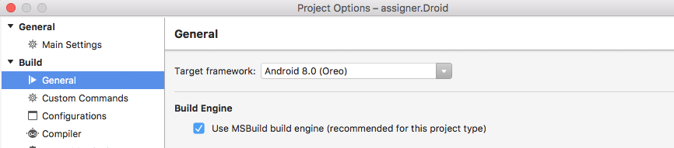

Install the latest Android SDK for emulator and solution in Tools->SDK Manager

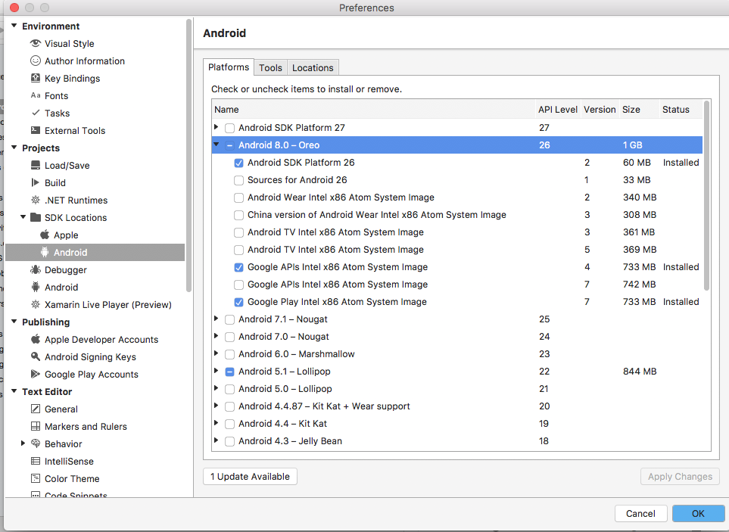

Install the Lollipop Android SDK for emulator

Create a Moto G emulator profile in AVD Manager.

Update Packages for both Droid and iOS.

Add package MVVMLightLibs to both droid and ios frameworks.

Add package Xamarin.TestCloud.Agent to iOS project

In the iOSProject, find the AppDelegate.cs, and start Calabash:



Since the ENABLE_TEST_CLOUD compiler directive is only defined in Debug mode the Calabash will not be present in the Release version, which would have resulted in rejection from Apple Store.

# Setup the MVVMLight framework

Add a new project for MVVM framework as a portable library

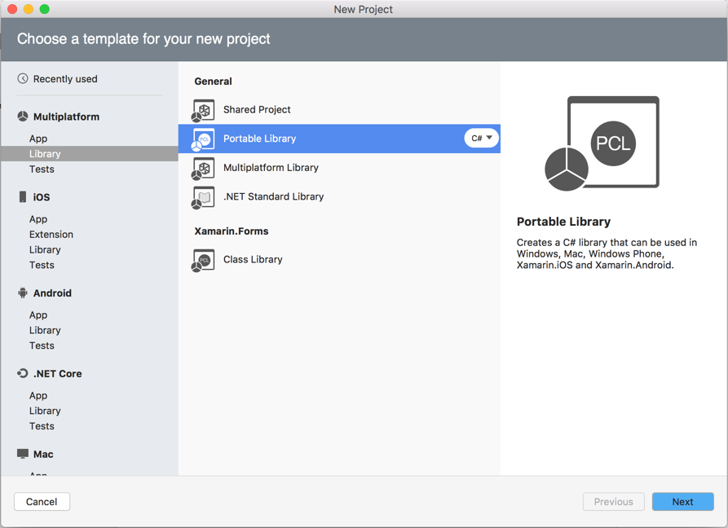

Add MVVMLightLibs and Xamarin.Forms package to this framework

Copy the MVVMFramework/_init directory from reference repo to this framework

Copy the MVVMFramework/Initializer.cs from reference repo to this framework

Delete MyClass.cs file from the project:

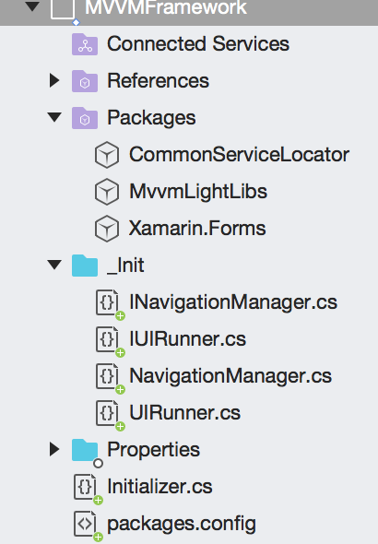

Reference this framework in Droid and iOS projects:

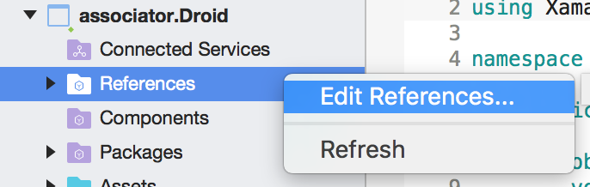

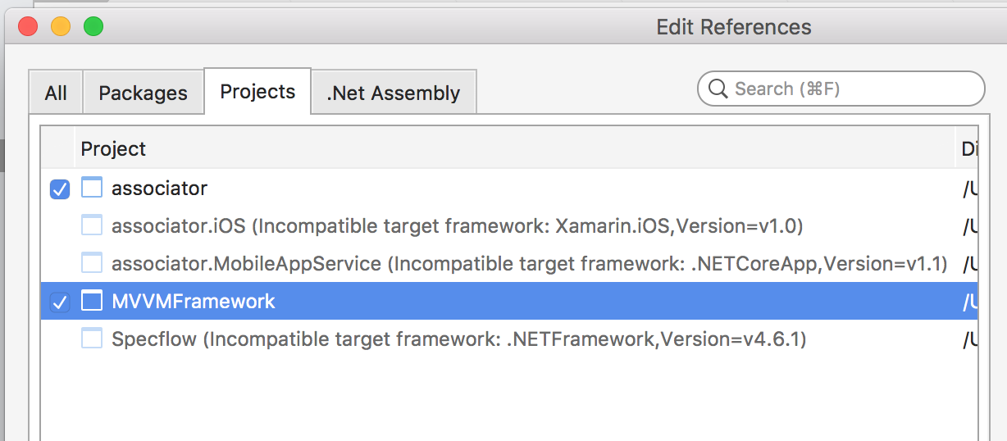

# Add BDD Project

Add a new Specflow project from miscellaneous section

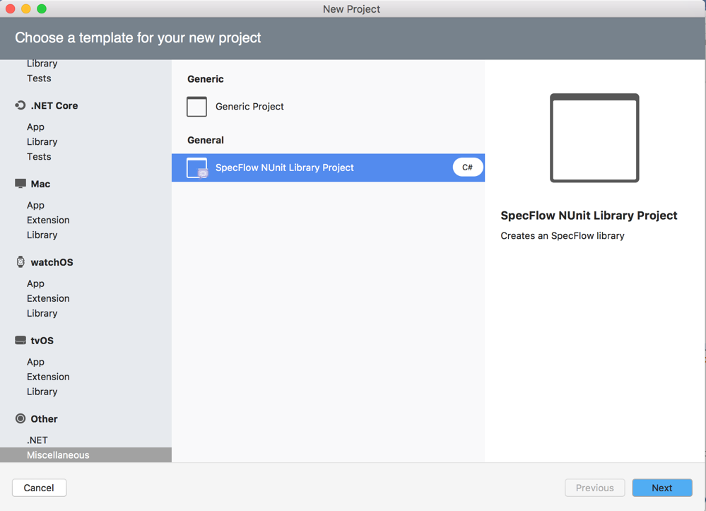

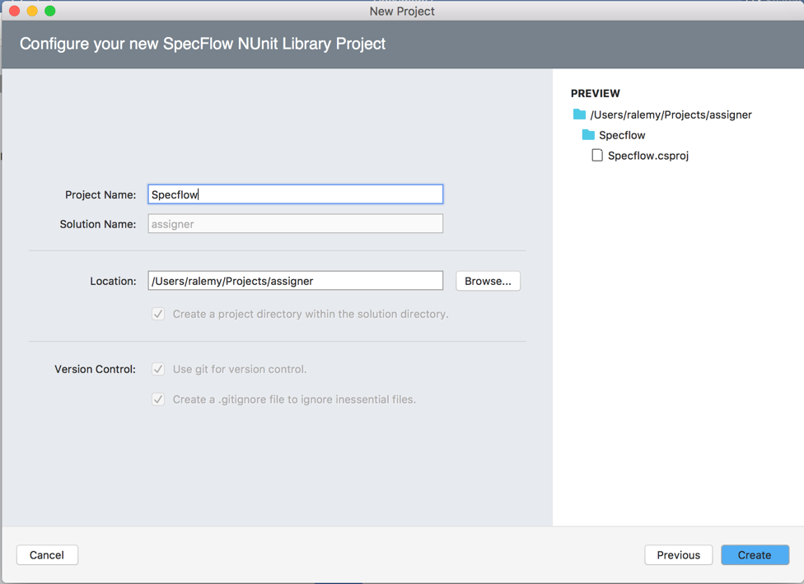

Update packages on Specflow project.

Remove Specflow.NUnit and NUnit packages

Add Xamarin.UiTest, NUnit (2.6.4), Docopt.Net and Should packages to Specflow project.

* Please note: **based on Xamarin.UITest documentation at the time of this writing, NUnit 2.6.x is the only supported version. Do not install higher versions**.

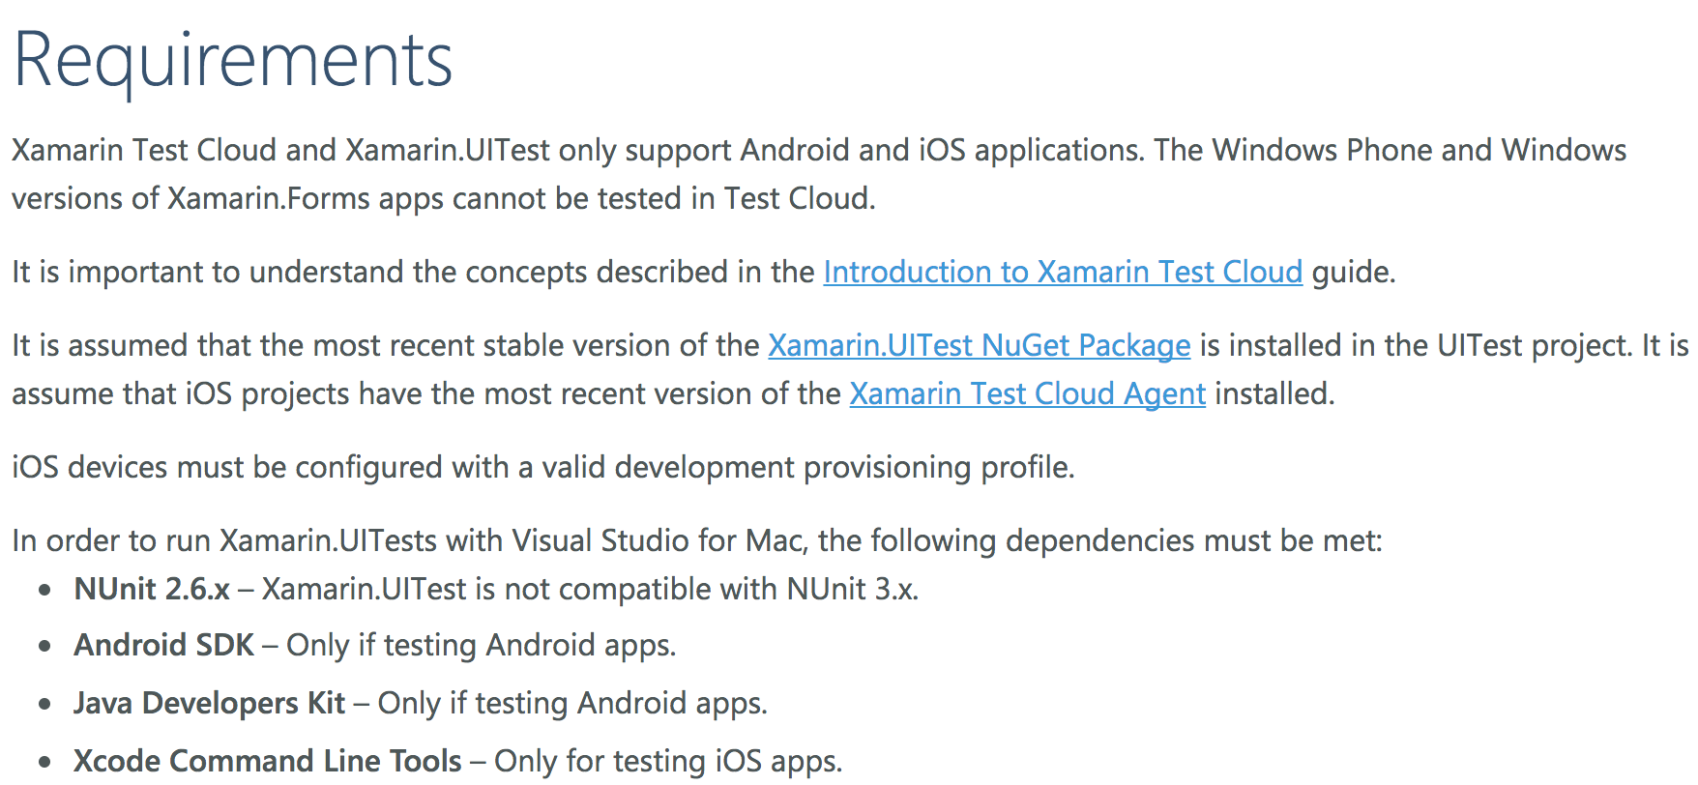

Open the UnitTest pad from the View menu and add the droid and iOS projects as Test Apps

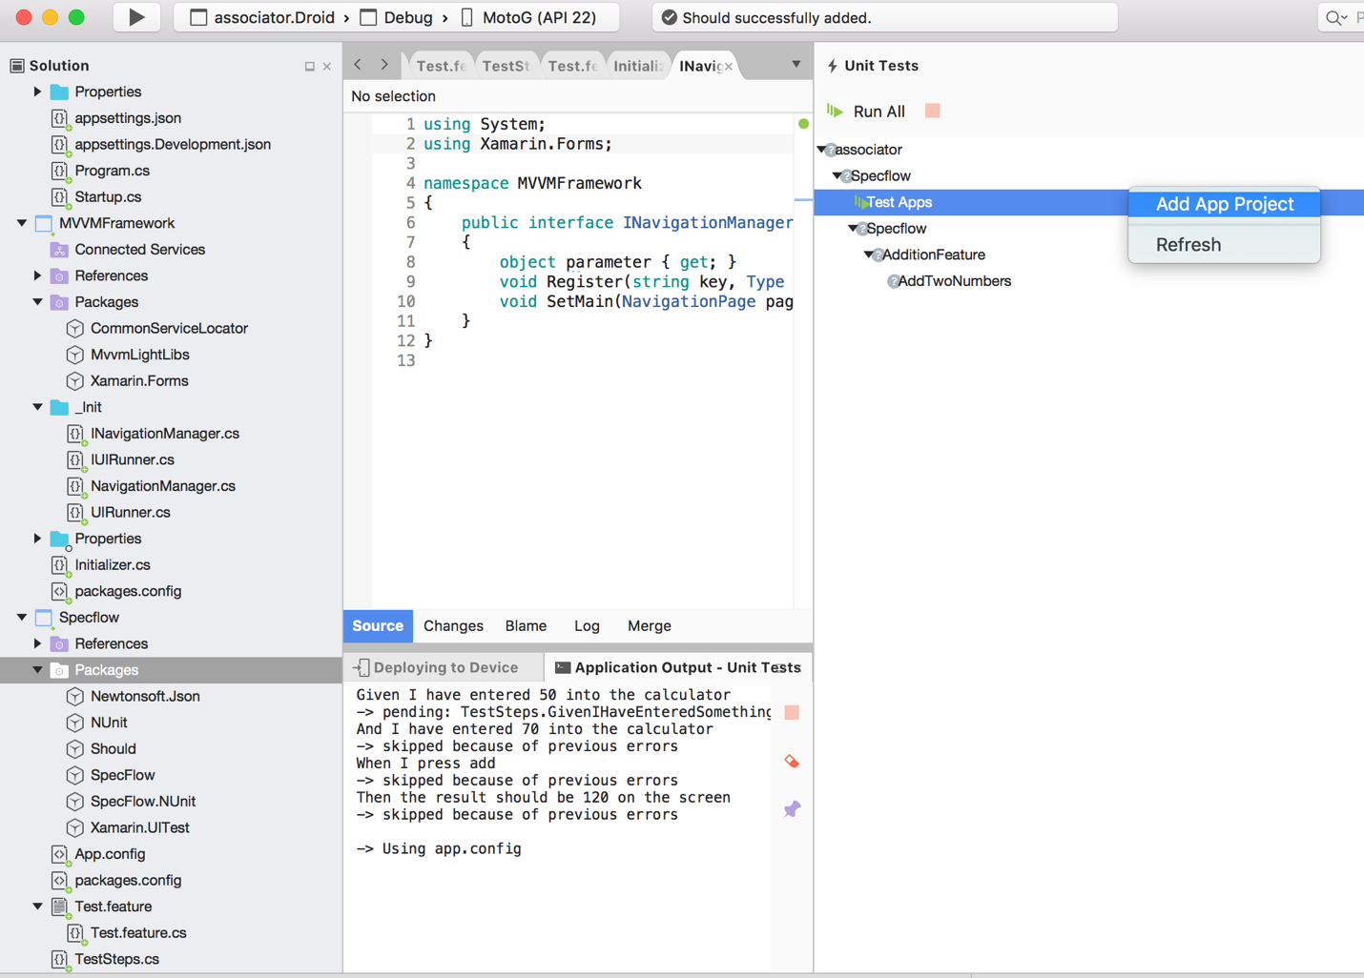

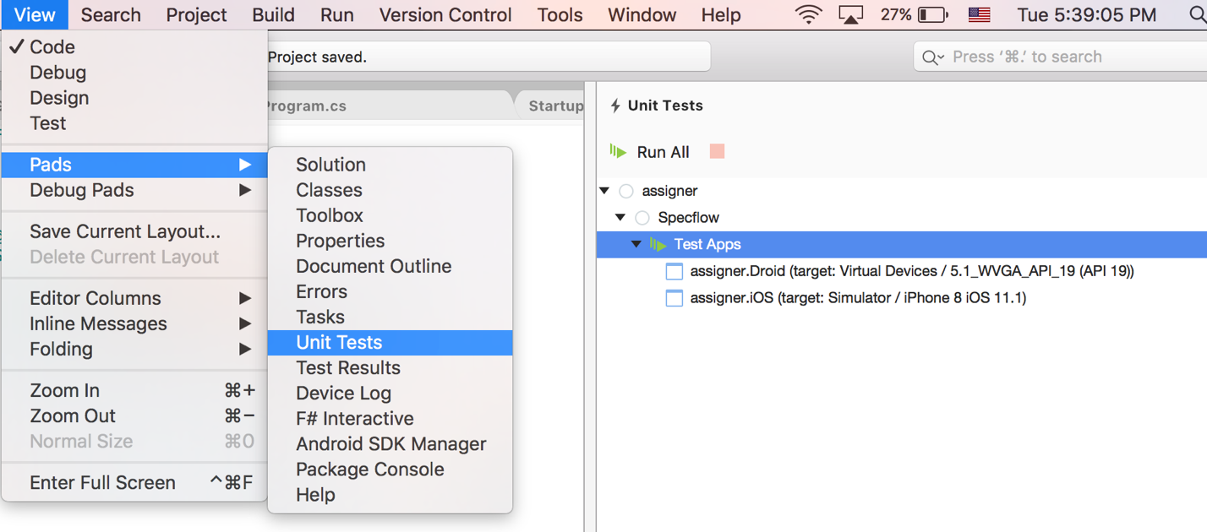

put the AppInitializer.cs in the Specflow project.

Copy Features directory from reference repo to Specflow.

Copy Screens directory from reference repo to Specflow.

Copy Steps directory from reference repo to Specflow.

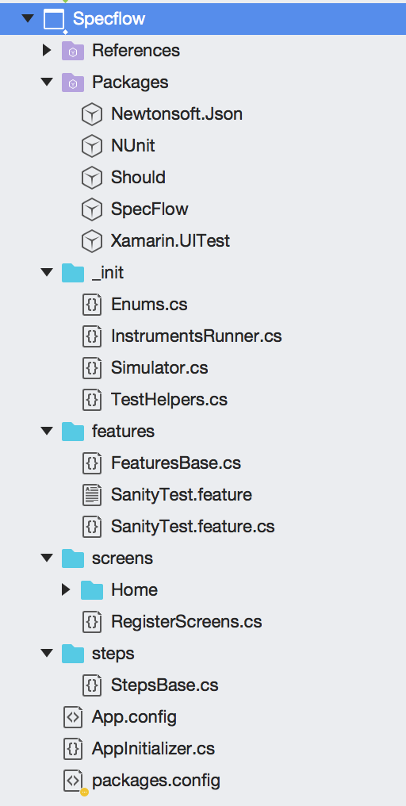

# Refactoring the Shared Project to MVVM model

From the shared project, remove all folders (Model, View, ViewModel) and files and just keep the App.xaml and App.xaml.cs.

## Structure of an MVVM page

Each MVVM page consists of three components, a xaml file, a xaml.cs file and a ViewModel file.

* The xaml file contains the markup for the page and should include an AutomationId for each element that is subject of UITests (more on this later)
* The xaml.cs file contains the code-behind, but in MVVM model it mainly serves two purposes
  + It contains a static PageKey attribute used for navigation
  + It assigns the BindingContext to the ViewModel file
* The ViewModel file contains all logic for the page, but is independent of UI and can be tested with Unit tests.

## Adding the First Page

Add a Pages and a ViewModels directory.

Add a Context Form page to Pages directory and call it MainPage

Add a Class to ViewModels directory and call it MainPageVM (it has to be a subclass of ViewModelBase)

Replace the contents of the App.xaml.cs to the following:



In the MainPage.xaml.cs, set the binding context to the View model object:

Put a simple component in MainPage.xaml. a good practice is to have the AutomationId and the PageKey be the same string.



# Running The Sanity Tests

At this point, all configuration should be finished and Sanity tests should be able to run. Selecting on what device the tests will run is done through FeatureBase.cs file.



each [TextFixture()] line will result in one instance of FeatureBase being created. The first parameter is platform, the second parameter is name of iOS simulator (so, empty for Android) and the final one is a Boolean to decide whether to reset the simulator or not (recommended for Android, but too time consuming for iPhone).

## Selecting Android Emulator to run

In the UnitTest pad, right click on the android test and select the simulator you want

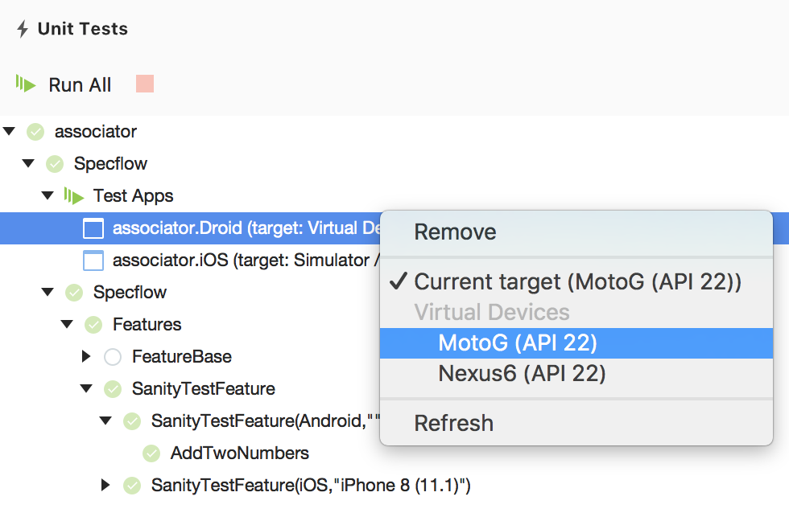

The FeatureBase file then needs to have a TextFixture annotation for running Android apps:

## Selecting iOS Simulator to run

Selecting iOS Simulators are bit more complex. First, it depends on the Mac OSX machine and version. Assuming that XCode command line tools are installed (which they need to be), the list of available simulation devices can be obtained by executing the xcrun instruments command.

This command returns the name of the device followed by the GUID of the device and whether it is a device or a simulator. The output of this command should be used for selecting the device name, which is the second argument to the TextFixture annotation. For example, to run tests on iPhone X iOS 11.1 the command is executed as follows:



Thus, the simulator name will be “iPhone X (11.1)”. this can be put directly in the TextFixture annotation:



Alternatively, there is a Enum.cs file in the _init directory that has constants defined for convenience. These were up to date as the time of this writing, but will certainly change in the future and readers should feel free to update the file for their own convenience.

For example, different iPhone 8 options are gathered in the same class:



and a fixture running on simulation for iPhone 8 plus and Apple watch 42 mm would look like the following:



## Running tests on Xamarin Test Cloud

[To be added]

## Running tests locally

At this point, what is needed is to run the tests locally is to open the Unit Tests pad and click on Run All button:

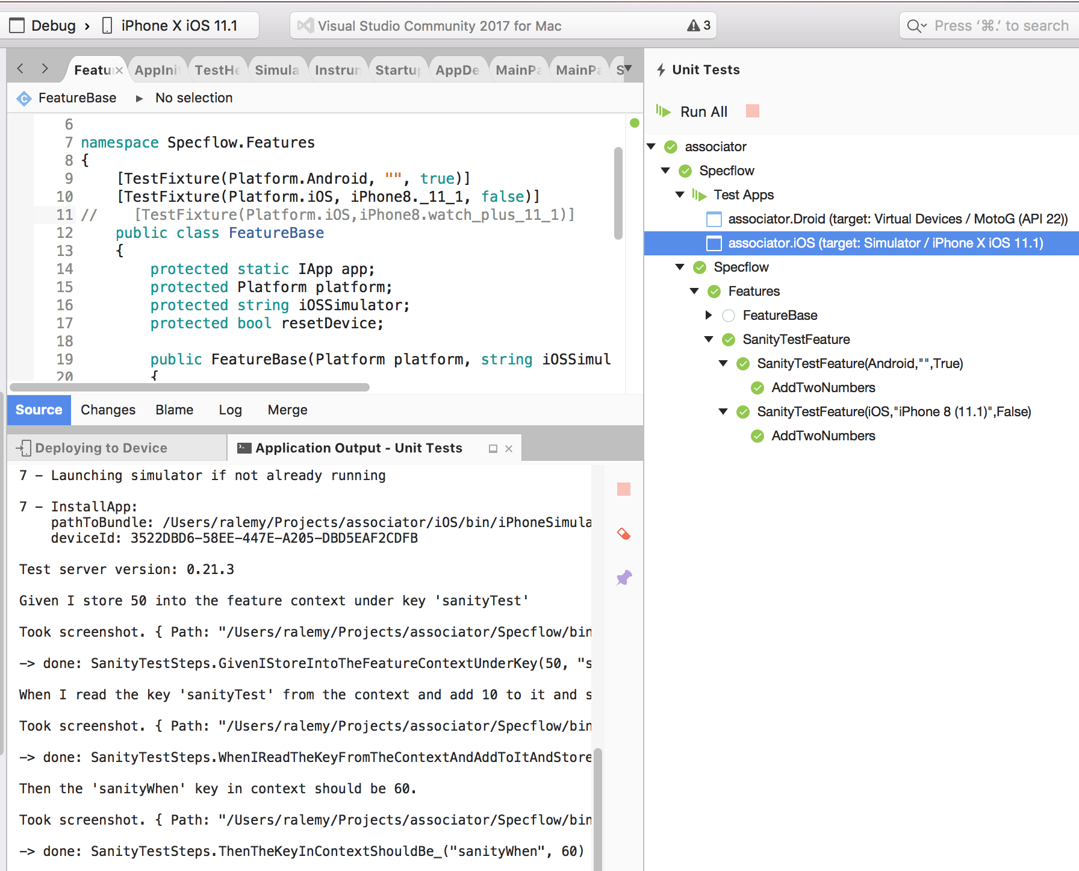

to be sure, change the assertion in SanityTestSteps.cs file to look for something different than the expected value, for example, add 10 to it:



This should result in test failing

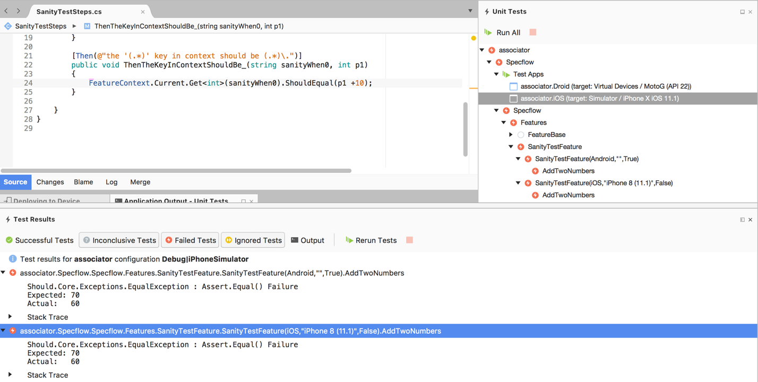

Section 2- General Techniques in Developing the Application

# The TDD/BDD protocol

Application is developed following the TDD protocol, i.e. first a test is written against the required behavior, which will fail. Then enough code will be added until the test passes, then the code is refactored to comply with coding standards. The cycle is then repeated, with test followed by code until test passes followed by refactor, until all the requirements and features are implemented.

The technique has a three nuances. First, one should stop writing test as soon as one can make the test fail. For example, once you notice you need an object that is not defined, that is a failing test. You should stop and go to the next step.

Second, one should stop writing code as soon as the test no longer fails. So once you define that object, you should not continue implementing all its method. You should go back to test writing until one of your tests fails because it needs a method on the object.

Third, once the test pass, both code and test code need to be refactored. It is important to apply refactoring only on the passing test scenario so that the codebase can be reset to the passing stage.

If you are using Git, that means committing at end of each of the above three steps.

## Writing the smallest failing test:

If you don’t already have a feature for this scenario, add a feature file to the features directory of the Specflow project.

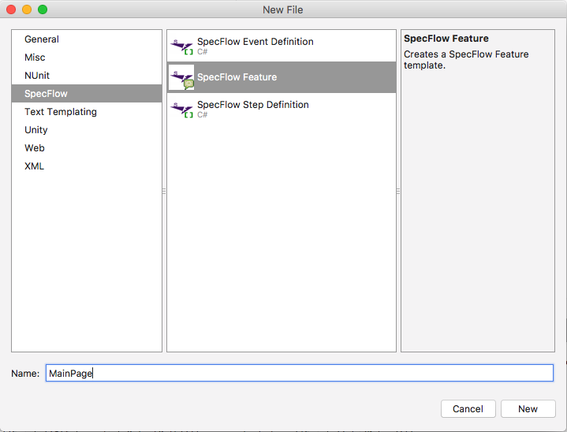

Write the first scenario and assign a decorator to it.



Save the file. This will generate the first part of partial class for feature.

Create the second part of partial class for the feature in the feature directory

* This second part is a subclass of FeatureBase class.



Run the test. This will fail but in Application Output pane it will print useful templates for step functions.

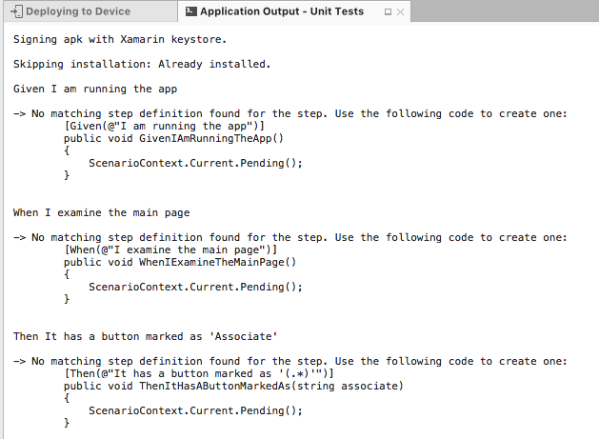

There, we have the smallest failing test. But it is failing because of test code, not production code, so let’s continue with writing more test code.

Add a Steps file to the Steps directory. One convention to use is to set the name the same as the scenario or it’s tag:

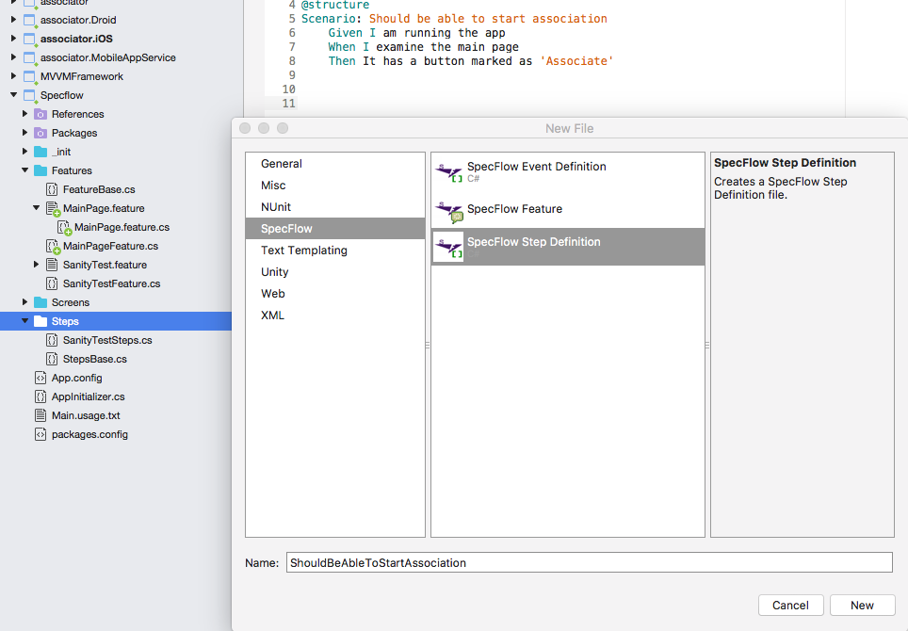

In the source code, set the superclass to StepsBase, and use the template of the test runner to create steps for the scenario.



This is now a failing step because of production code, since there is no way to check if the test is examining the main page. Very frequently the test needs to know about specific pages or components on the page.

## Making the test pass with minimum code

Xamarin.UITest allows for components to have a “AutomationId” attribute, which the test can query to find or check for the component they need. Refactor the MainPage.xaml file to add an AutomationID attribute to top element of the page required for this test.



At this point, we can refactor the step to check if such element exists.



### Using app.Repl()

To detect the elements of the page and correct statement to apply for the tests, Xamarin allows for a very useful command called REPL. Essentially, when the test contains this statement, Xamarin stops and brings up a terminal for the user to type commands against the app and observe the responses so that the user can decide which command is best to detect the feature in which the user is interested. For example, the above test should have started like this:

Once the execution reaches this line, Xamarin will stop and display a terminal that can be used to execute commands and see their results. This terminal supports command completion and copying history to clipboard, which are very useful to navigate complex structures.

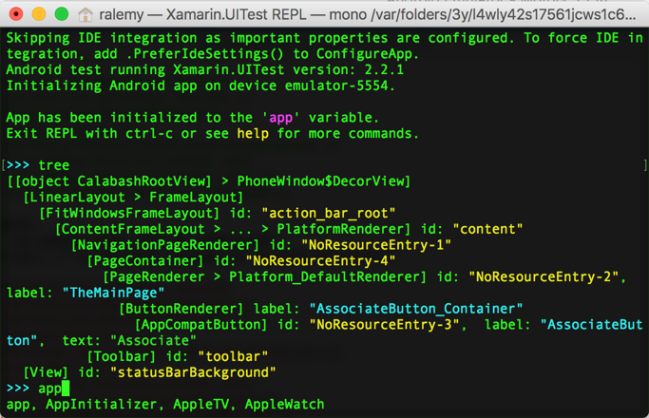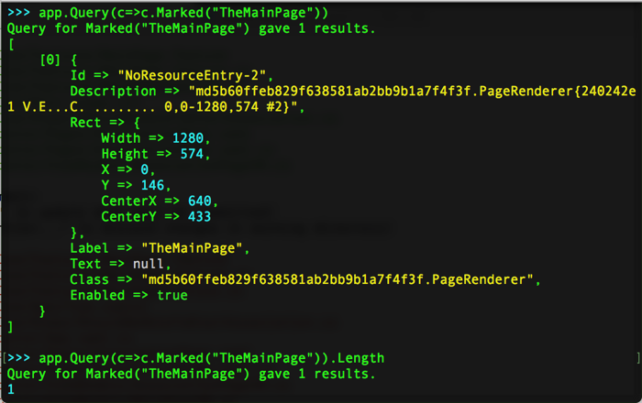

This shows what the correct test should be. Now the user can exit the Repl by typing quit or exit.

## Refactor, and Repeat.

We can then use the same technique to check for a button that is marked as expected:



Which will fail, and we should go and add the button to the page.



At this point, the tests will all pass. We have proven that the button is there and it has the right label. Next, is to prove it will work.

# Adding Button Actions to the application

To allow a button to execute a command, three components work with each other.

* In the xaml file, the command attribute of the button is set to a binding



* In the ViewModel file, a public command variable is declared which will receive the click or tap as part of binding.



* The ICommand is initialized in the constructor, and pointer to a method or action is sent to it. This method is where the code for the command exists, and it can be executed and tested with unit tests.



## Navigation to other pages

If the button is supposed to trigger navigation to another page, then the other page should be created as explained above:

* The xaml file should have an AutomationID at root element for the page to be identifiable to tests



* The ViewModel file must be a subset of ViewModelBase object.



* The xaml.cs file should have a public static PageKey to identify the page object to the navigation manager, ideally the same value as AutomationID. The xaml.cs also file should have a BindingContext set to the ViewModel object retrieved from the dependency injector.



* Finally, in App.xaml.cs the Page object should be registered with the navigation manager under the PageKey



Once such page exists, the ViewModel that controls the command of the button can switch to that page. The navigator is received from the dependency injection system.



# Testing a new page

One of the more popular practices in BDD and end-to-end testing of multi-page applications is to create a Page object. The page object takes care of how elements are addressed and found. This technique has multiple advantages in maintainability and scalability. For example, if the text of the button changes, there would be no need to refactor all tests that are referring to that button.

## Creating a Page Test Object

A page test object is a plain C# object that contains methods for identifying the page, making sure it has been loaded, and identifying pertinent components on the page. In the example of AssociationPage



The first step is to add a C# interface for the page, which can go in a directory called Association in the Screens folder of the Specflow project



If needed, this can be inherited by multiple different implementations (for example Android vs iOS), but for this writing, one implementation is enough



One last step is to register the object in the dependency injection in RegisterScreens.cs



## Scenario for a button navigating to page

As described above, a scenario is added to the MainPage feature file, after the scenario that makes sure the correct button exists.



Run the test once to generate the template and then add a Specflow Step file as explained above and write the test code. Here is how it should look like.



See that the first test is not using a Page test object, and needs to know the exact id of the page container. But the second page is using a Page test object, so it can use code completion, and also in the future the way that the PageContainer is detected may change without requirement to refactor the tests.